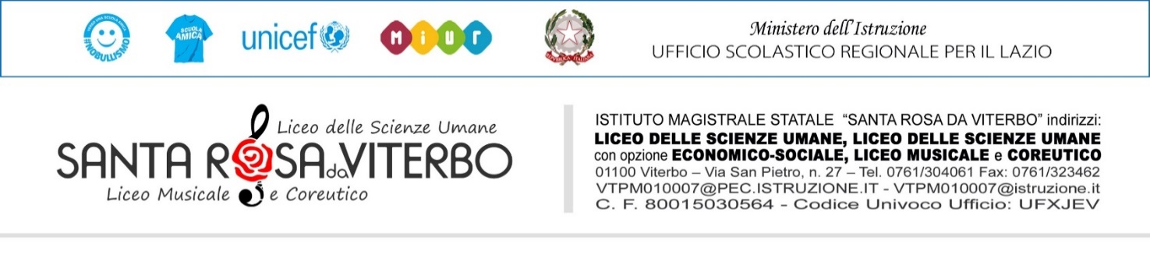
VERBALE_ Riunione del Comitato Studentesco
Il verbale va compilato durante la riunione, firmato dai rappresentanti e inserito entro 2 gg, in formato cartaceo, nell’apposita cartellina in VP, o in formato elettronico (USB) sul PC piccolo in VP.
Verbale n°____
Il giorno________________ giorno della settimana_______________ dalle ore_________, alle ore_____________presso________________________________
si è svolta, come da regolare comunicazione al DS del giorno _____________ la riunione del Comitato Studentesco, per discutere il seguente ordine del giorno:
- _________________________________________________________________________
- _________________________________________________________________________
- _________________________________________________________________________
- _________________________________________________________________________
- _________________________________________________________________________

CLIMA DI COLLABORAZIONE E PARTECIPAZIONE
(Riportare la valutazione che l’assemblea attribuisce ai due aspetti)

- Clima di collaborazione: Adeguato Non adeguato Scarso

- Partecipazione: Attiva e costruttiva Passiva Assente

SINTESI DELLA DISCUSSIONE:
- ____________________________________________________________________________________________________________________________________________________________________________________________________________________________________________________________________________________________________________________________________
- ____________________________________________________________________________________________________________________________________________________________________________________________________________________________________________________________________________________________________________________________________
- ____________________________________________________________________________________________________________________________________________________________________________________________________________________________________________________________________________________________________________________________________
- ____________________________________________________________________________________________________________________________________________________________________________________________________________________________________________________________________________________________________________________________________
- ____________________________________________________________________________________________________________________________________________________________________________________________________________________________________________________________________________________________________________________________________
OSSERVAZIONI/PROPOSTE: riportare in modo sintetico le osservazioni e le proposte emerse
_____________________________________________________________________________________________________________________________________________________________________________________________________________________________________________________________________________________________________________________________________________________________________________________________________________________________________________________________________________________________________________________________________________________________________________________________________________________________________________________________________________________________________________________________________________________________________________________________________________________________________________________________________________________________________________________________________________________________________________________________

Letto ed approvato il verbale, la riunione ha termine alle ore_______________
I rappresentanti d’Istituto
_________________________
_________________________
_________________________
_________________________

A cura della FS Supporto Studenti 2022/2023

